 | 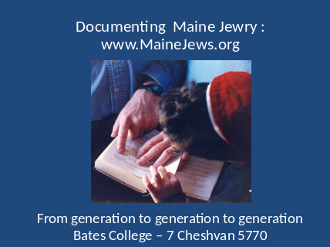
 | 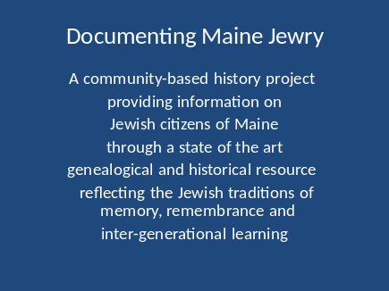 | In program terms, www.MaineJews.org is an information resource and a software platform to share experiences about Maine Jewry. DMJ is also a relaxed, informal group of Mainers collecting oral histories and supporting local communities with their own historical reflections.
 | 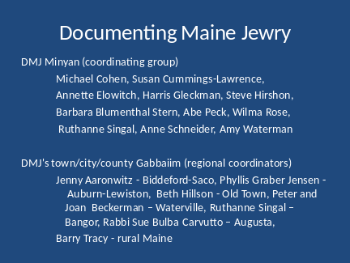 | Most of DMJ’s work is done by volunteers. Currently volunteers are needed to review census data, arrange collection of data from various communities and organizations, develop educational programs for Hebrew schools, and upgrade the software. Community organizations and synagogues are invited to share access to DOMJ’s resources by adding links to www.MaineJews.org on their websites; DOMJ database currently includes links to all known Maine Jewish websites.
 | 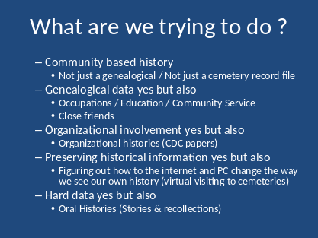 | DOMJ’s on-line information has come from over 400 individuals, all the Maine Jewish cemeteries, most of the state’s synagogues and major community organizations, a good number family genealogists and historians, official state and federal records, Ancestry.com and JewishGen.org
 |  | What we collected to date :  25,800 individual records  Of which 12,700 have parent information  Of which 6,861 have spouse information  Of which 2,845 have Hebrew names  Of which 8,478 have children information  Of which 10% have community service information  Of which 0.5 % have occupational information  What could be added :  Memorial boards from Auburn, Bangor, Rockland  B’nai Mitzvah , naming and marriage records  Hebrew school attendance records  1920 and 1930 US Census records  Additional family histories  Jewish camp enrollment records
 | 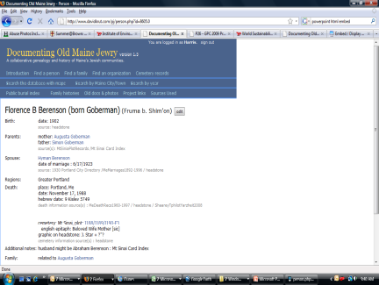 | Individual biographic and genealogical data - the software encourages users to update on-line information on their family and friends; information and scanned photographs and documents can also be emailed to dopj@mindspring.com for uploading offline
- | 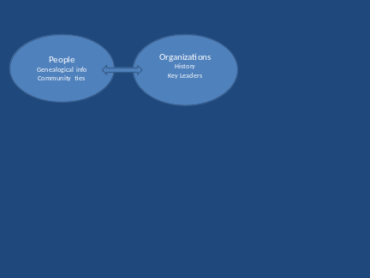 | What we collected to date :  872 organizational records  Of which 100 are Maine Jewish religious institutions  Of which 183 are Maine Jewish community organizations  Of which 321 are Maine “Jewish businesses”  Of which 19 are Maine Jewish cemeteries  Of which 15 are Maine Jewish camps  What could be added :  histories and leadership of key organizations  additional photographs of Maine Jewish community buildings and events  locally important “Jewish business” with their business activities and owners  Additional links between organizations (splits, mergers, and spin-off organizations)
 | 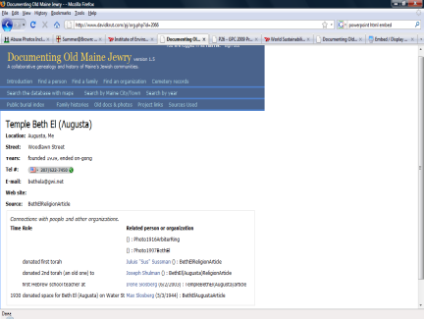 | Organizational Information and history - the software links individuals to organizations as well as organizations to each other
 | 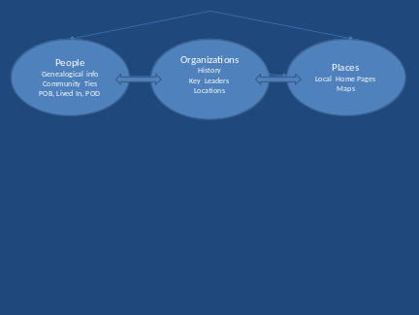 | What we collected to date :  Ties of 18,251 individuals to specific Maine places  Ties of 2,015 individuals to places in “the old country”  Ties of 2,216 Maine individuals with places “from away”  What could be added :  Town and city home pages  Basic histories of Maine Jewish communities  Additional details on the immigrant shtetls  Street and district areas within Maine cities and towns with large Jewish populations centers in each decade
 | 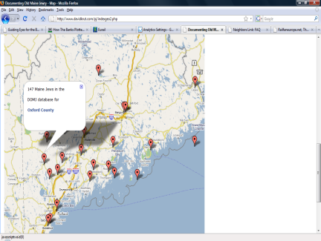 | Geographic data is mapped with Google to specific areas of the state and hot linked to the home pages for that area
 | 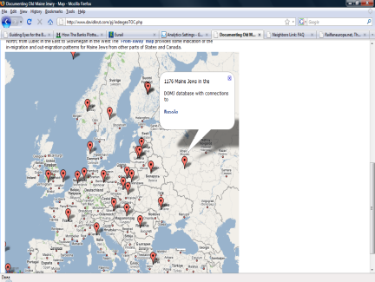 | Geographical data is also mapped with Google to specific Old Country Places as well as to state and provinces from away. The underlying geographic locations does reflects both precise knowledge of locales (e.g. Birzai, Lithuania) and quite vague references such as those used in census and immigration records (e.g. Russia)
 | 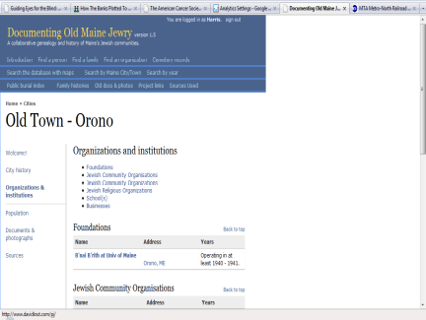 | Local home pages are new ways for each separate Maine community to have their own “history” and presence within the wider state resource of www.MaineJews.org. The software permits users to use all the search and report features of the website for a specific locale.
 | 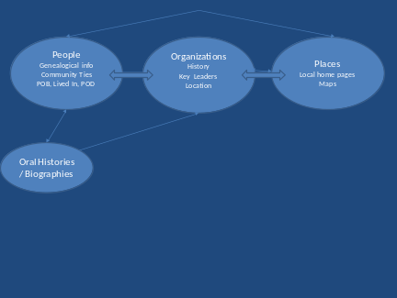 | What we collected to date :  85 oral histories and family recollections  Of which 37 are 2009 DOMJ sponsored interviews of Portland area Jews  Of which 40 are 1977 JCC sponsored interviews of Portland area Jews  Of which 18 are in Risen’s book, Maine Jewels  Of which 9 are in the USM Life Story Center collection  What could be added :  oral histories from around the state  additional family reunion records  thematic indexes to the existing collection of 77 audio interviews  historical contexts referenced in the oral history interviews (what was the WPA, what was the importance of the Maine liquor licensing law , etc)
 | 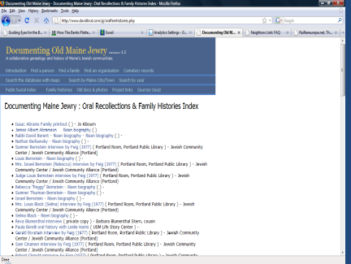 | With support from the Maine Humanities Council, DMJ has trained a group of oral historians who have been collecting oral histories from Greater Portland-are Jews. These oral histories will be audio indexed and together with a 1977 Jewish Community Center supported effort, shared on the web on our website and that of the Portland Public Library
 | 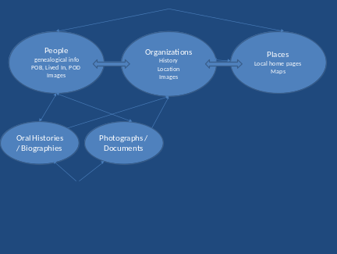 | What we collected to date :  over 200 pages of scanned documents  38 old photographs (excluding headstone images)  2,685 headstone images from Mt Sinai, Mt Carmel, and Smith St cemeteries  What could be added :  headstone images from the other 16 Maine Jewish cemeteries  scanned documents (newsletters, local histories, family reunion notes, etc ) from other attics , basements, and closets
 | 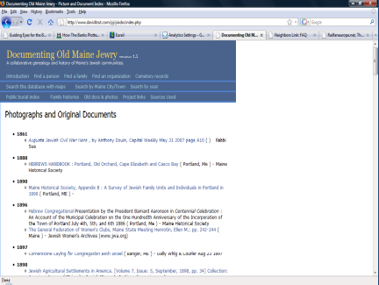 | The photographs and document section contains scanned copies of original documents, research studies, community commemorative publications and group photographs from Jewish community events. The software links references in these documents and photograph to biographic records of identified individuals and organizations
 | 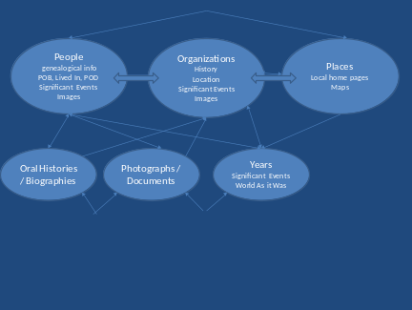 | What we collected to date :  240 milestones in Maine’s Jewish history  260 milestones in contemporary Jewish history  What could be added :  additional local data points from Maine’s Jewish history  additional contemporary context references
 | 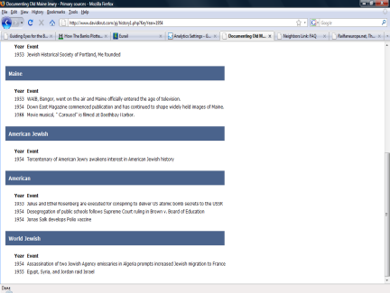 | Year by year historical milestones is intended to provide a context to understand the biographic, organizational, and primary documents. In the near future, it is expected that the software will permit examining the data as the “Maine Jewish world” was in a given decade (e.g. what did the state’s Jewish community look like in the 1920s)
 | 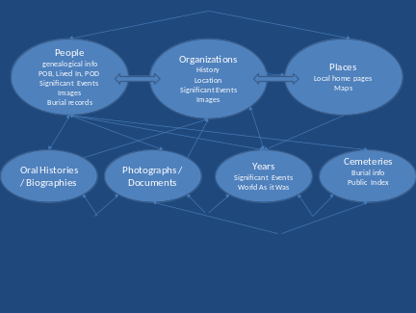 | What we collected to date :  Core records from all 19 Maine Jewish cemeteries  Including 5,665 records from Portland area cemeteries  Including 1,673 records from the Bangor cemeteries  Including 682 records from the Lewiston-Auburn cemeteries  Including 104 records from the Rockland cemeteries  The re-document of Mt Sinai and Smith St s  What could be added :  annual updates of burials at all Maine Jewish cemeteries  Jewish burials in the Maine-based Veteran cemeteries and other public cemeteries  plot maps for the 19 cemeteries  additional headstone images
 | 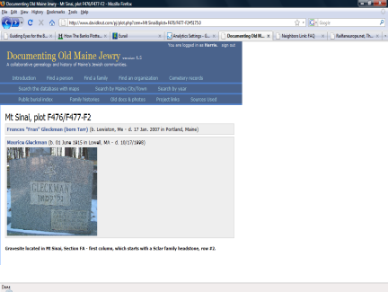 | The cemetery records provide access to plot by plot location information as well as headstone photographs. The website allows a virtual cemetery visit by providing the El Maleh Rachamin memorial prayer in Hebrew and transliteration in a side window with the headstone image
 | 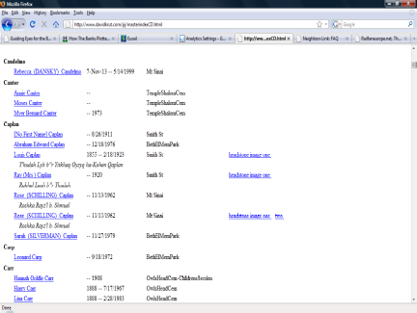 | The public state Jewish burial index is the only portion of the site accessible without registration and an approved password. It is frequently the page referenced by on-line search engines (e.g. Google)
 | 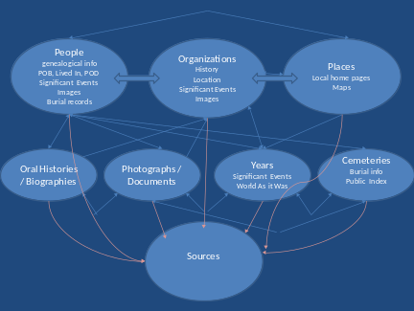 | What we collected to date :  382 documentary sources  Over 400 contributions of personal knowledge via on-line editing, attachments, and other electronic submissions  What could be added :  Family updates of their own histories  Other census and city business directories
 | 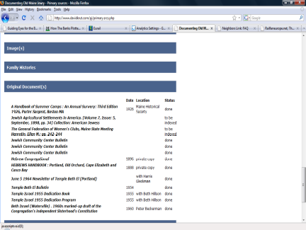 | All the crucial information in www.MaineJews.Org is sourced. The on-line biography also includes the name of the donor, the name of researcher, and the location of the original material.
 | 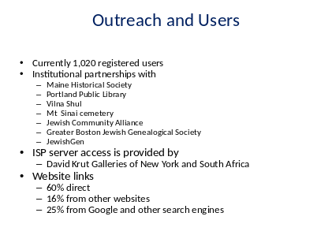 | With DMJ is principally a volunteer organization. It does require financial support. Currently DMJ is seek $4,500 to prepare an audio-index of the oral histories, $6,000 to upgrade the software, $7,000 for a set of traveling set of educational posters, and $12,000 for support and ISP resources. DOMJ is under the financial support of the Jewish Community Alliance, Portland, a 501(c) 3 organization.

